

**School of Information Technologies**

**Faculty of Engineering & IT**

**ASSIGNMENT/PROJECT COVERSHEET - GROUP ASSESSMENT**

**Unit of Study: COMP5048**

**Assignment name: Assignment 2-Flights data set (flight delay data) Final Report**

**Tutorial time: 20:00 Thursday Tutor name: Nguyen Quan**

**DECLARATION**

We the undersigned declare that we have read and understood the*University of Sydney Academic Dishonesty and Plagiarism in Coursework Policy,*an, and except where specifically acknowledged, the work contained in this assignment/project is our own work, and has not been copied from other sources or been previously submitted for award or assessment.

We understand that failure to comply with the Academic Dishonesty and Plagiarism in Coursework Policy can lead to severe penalties as outlined under Chapter 8 of the University of Sydney By-Law 1999 (as amended). These penalties may be imposed in cases where any significant portion of my submitted work has been copied without proper acknowledgement from other sources, including published works, the internet, existing programs, the work of other students, or work previously submitted for other awards or assessments.

We realise that we may be asked to identify those portions of the work contributed by each of us and required to demonstrate our individual knowledge of the relevant material by answering oral questions or by undertaking supplementary work, either written or in the laboratory, in order to arrive at the final assessment mark.

SIT Building, J12 **T** +61 2 9351 3423 ABN 15 211 513 464

The University of Sydney **F** +61 2 9351 3838 CRICOS 0

NSW 2006 Australia **E** sit.info@sydney.edu.au

**sydney.edu.au/it**

Project Final Report ----- **Group 30**

Flight Data Visualisation

****

**29.10.2017**

**Revision History**

|  |  |  |  |  |
| --- | --- | --- | --- | --- |
| Revision | Date | Status | Author | Summary of Changes |
| 0.1 | 29-Oct-2017 | Completed | Girish | Initial Draft |
|  |  |  |  |  |
|  |  |  |  |  |
|  |  |  |  |  |
|  |  |  |  |  |

**Table of Contents**

[1. Aim & Contributions 5](#_Toc497068498)

[1.1 Aim 5](#_Toc497068499)

[1.2 Contributions 6](#_Toc497068500)

[2. Data Set 7](#_Toc497068501)

[3. Design 9](#_Toc497068502)

[3.1 Framework of VA System - A hitchhiker’s guide to U.S.A. 9](#_Toc497068503)

[3.2 Analysis & Final Visualisation 10](#_Toc497068504)

[3.2.1 Visualisation 1: Flight Network-View Overview 10](#_Toc497068505)

[3.2.2 Visualisation 2: Flight Network-View Delay Breakdowns 11](#_Toc497068506)

[3.2.3 Visualisation 3: Flight Network-View Interactive 12](#_Toc497068507)

[3.2.4 Visualisation 4: Seasonal Effect 13](#_Toc497068508)

[3.2.5 Visualisation 5: Airline Performance 14](#_Toc497068509)

[3.2.6 Visualisation 6: Best/Worst Airport 15](#_Toc497068510)

[3.2.7 Visualisation 7: Delay reasons and types Correlations 16](#_Toc497068511)

[5. Evaluation 19](#_Toc497068512)

[5.1 Results 20](#_Toc497068513)

[5.1.1 Survey (Questionnaire) 20](#_Toc497068514)

[5.1.2 Survey (Interview) 24](#_Toc497068515)

[5.1.3 Empirical evaluation (statistical analysis) 25](#_Toc497068516)

[5.2 Discussion 26](#_Toc497068517)

[6. Conclusion 27](#_Toc497068518)

[7. References 28](#_Toc497068519)

[8. Appendix: Group meeting minutes 29](#_Toc497068520)

[9. Appendix: Code 42](#_Toc497068521)

# 1. Aim & Contributions

## Aim

The following objectives/questions were identified that will form the subject of this visualisation exercise and the VA system.

1. Visualise best time of year for travelling with minimal flight delays.

• Any specific seasons/months is good or bad for travelling;

• Weekends cause more delay than weekdays;

• Any specific airport or air route to avoid while travel booking.

1. Visualise performance of airports and carrier year on year

• Best performing airport

• Worst performing airport

• Best performing airline/carriers

• Worst performing airline/carriers

1. Visualise negative effect of specific incident or event on flight delay

• 1999-2000 Y2K bug effect on flight delay

* 9/11 World trade centre terrorist attack effect on flight delay

**d.** Visualise best performing airport(s) performance for a single year.

## Contributions

|  |  |  |  |  |
| --- | --- | --- | --- | --- |
| **Project Team Members** | | | | |
| **Student name** | **Student ID** | **Contribution** | **Agree to Share** | **Signature** |
| *Nagib Shah* | *470360839* | *16.66%* | *Yes* |  |
| *Xinan Ma* | *470489934* | *16.66%* | *Yes* | signature paper_副本 |
| *Alan Shen* | *470194809* | *16.66%* | *Yes* | sig2 |
| *Young Choi* | *470346338* | *16.66%* | *Yes* | signature young |
| *Qiushi Zhang* | *470119101* | *16.66%* | *Yes* | signature rachel |
| *Girishkumar Dhotarkar* | *470351620* | *16.66%* | *Yes* |  |

# 2. Data Set

After analysing each data sets, finalized data set is **Flight (delay) data set** available on [***http://stat-computing.org/dataexpo/2009/***](http://stat-computing.org/dataexpo/2009/). The dataset contains largely US domestic flight network and performance details consisting of approximately 120 million flight arrival and departure information, metrics, and statistics ranging from the years 1987 till 2008. Furthermore, the dataset also contains airline/carrier, airport, and aircraft information that may provide useful insights.

After thorough study, cross reference, and consideration by the project team a decision was made to utilise the complete dataset (21 years approx.) for visualisation and analysis in order to present a complete and coherent summary of the US flight network and delay profiles. The following table outlines the structure and content of the dataset in detail.

Table 1.1.1: Base data (ONTIME)

|  |  |
| --- | --- |
| **Name** | **Description** |
| Year | 1987-2008 |
| Month | Number |
| DayofMonth | Day |
| DayOfWeek | 1 (Monday) - 7 (Sunday) |
| DepTime | actual departure time (local, hhmm) |
| CRSDepTime | scheduled departure time (local, hhmm) |
| ArrTime | actual arrival time (local, hhmm) |
| CRSArrTime | scheduled arrival time (local, hhmm) |
| UniqueCarrier | [unique carrier code](http://stat-computing.org/dataexpo/2009/supplemental-data.html) |
| FlightNum | flight number |
| TailNum | plane tail number |
| ActualElapsedTime | in minutes |
| CRSElapsedTime | in minutes |
| AirTime | in minutes |
| ArrDelay | arrival delay, in minutes |
| DepDelay | departure delay, in minutes |
| Origin | [origin IATA airport code](http://stat-computing.org/dataexpo/2009/supplemental-data.html) |
| Dest | [destination IATA airport code](http://stat-computing.org/dataexpo/2009/supplemental-data.html) |
| Distance | in miles |
| TaxiIn | taxi in time, in minutes |
| TaxiOut | taxi out time in minutes |
| Cancelled | was the flight cancelled |
| CancellationCode | reason for cancellation (A = carrier, B = weather, C = NAS, D = security) |
| Diverted | 1 = yes, 0 = no |
| CarrierDelay | in minutes |
| WeatherDelay | in minutes |
| NASDelay | in minutes |
| SecurityDelay | in minutes |
| LateAircraftDelay | in minutes |

Supplemental data Tables:

Table 1.1.2: Airports data Table 1.1.3: Carriers

|  |  |
| --- | --- |
| **Name** | **Description** |
| iata | Iata (airport code) |
| airport | Airport Name |
| city | City Name |
| state | State Abbreviation |
| country | Country Abbreviation |
| lat | latitude |
| long | Latitude |

|  |  |
| --- | --- |
| **Name** | **Description** |
| Code | Code of Airline |
| Description | Name of Airline |

# 3. Design

## 3.1 Framework of VA System - A hitchhiker’s guide to U.S.A.

Figure 3.1.1: VA Framework

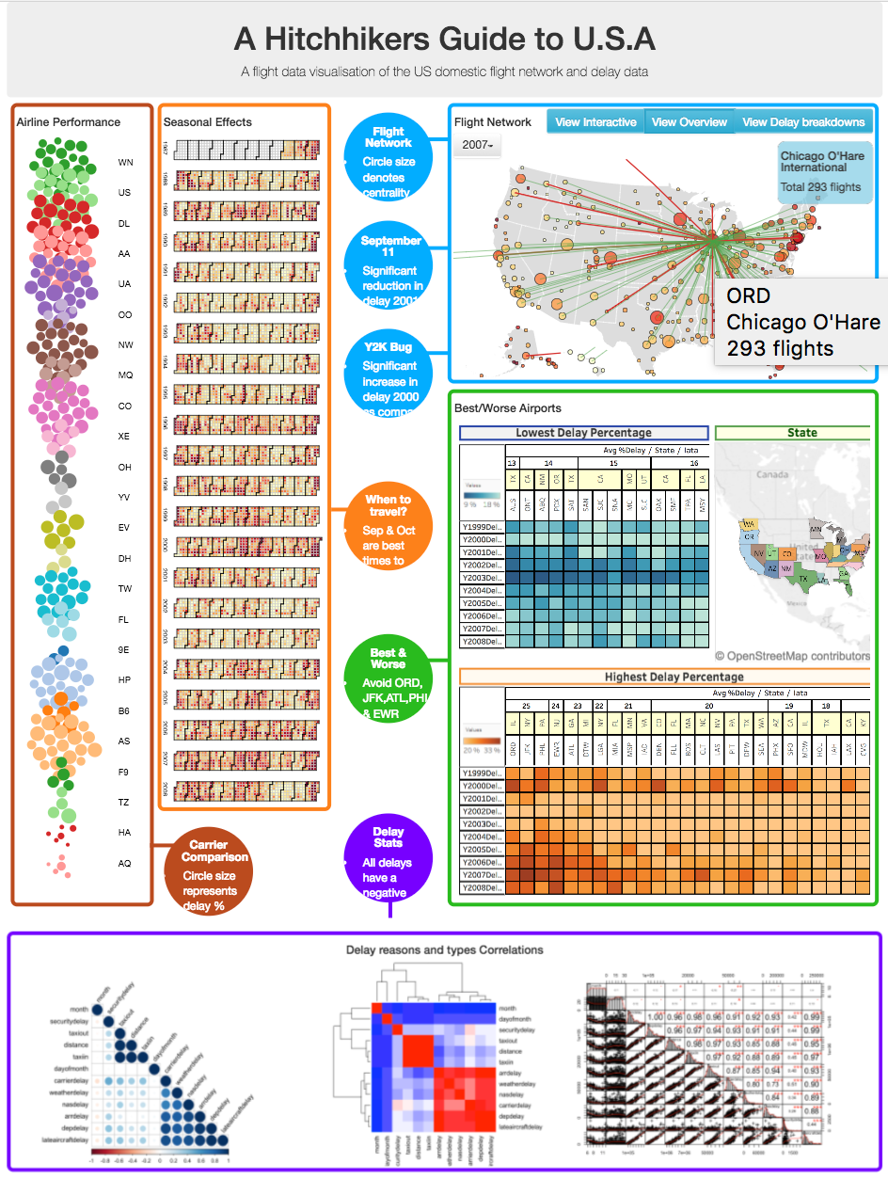

## 3.2 Analysis & Final Visualisation

### 3.2.1 Visualisation 1: Visualisation 3: Flight Network-View Interactive

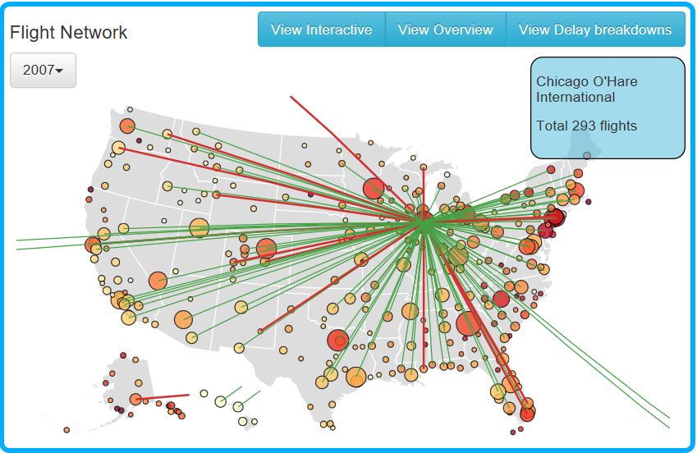

**Figure 3.2.1: Interactive Visualisation to show the networks of each airports / airlines by flight delay**

**Purpose:** By using D3 created Geo-spatial layout represent airports causing delay and its route by each year. This interactive visualisation will have drop down for year from 1987 to 2008 for effective summarisation of the network. Interaction with airport node (Hover) on graph to highlight network associated with airport alongside a brief summary.

**Nodes:** Identified in different colors by using **k-core analysis** in order to visualise sub-graph which represents most important airports. Airport circle size represent out-degree centrality, colour scale will be applied to indicate percentage delay.

**Edges** (Airlines route) in different color affected by flight delay for each airport

**Pros:**

* User interactive feature allow users to select year and airport for visualisation
* Highlighting node provides additional information about airport

**Cons:**

* Visualisation get bit messy if try to find flight delay for states away from USA main land like Alaska, Hawaii.

### 3.2.2 Visualisation 2: Flight Network-View Overview

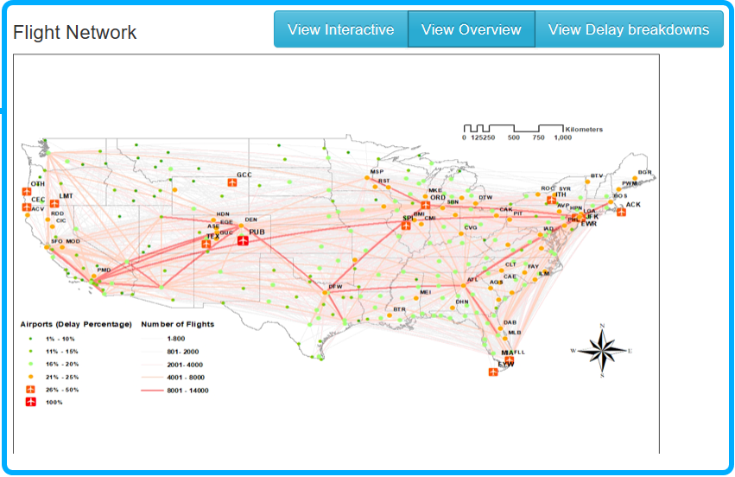

**Figure 3.2.2: Geo-Special Layout of USA Airlines In 2008**

**Purpose:** Creating Geo-spatial layout in **ArcGIS** which will represent airports and airline routes which cause most delay in entire network and give overview visualization to deliver the specific airports or routes to avoid while travelling

**Node**: Identified in different colours and sizes (signs) by using airport delay percentage, the higher the percentage of delay, the larger nodes size. However, the airport has 100% delay only has two airlines.

**Edges**: Representing airlines route in different weights affected by number of flights alongside custom edge attribute of delay percentage. This is done to reduce the overall edges within the network. The colour of the airlines by using transparent 40%. The red lines show the number of flights in this airline more than 8000.

**Pros:**

* Simple visualisation provide airports and routes cause most delay entire network
* Provide information which airports and routes need to be avoided while travelling

**Cons:**

* Not interactive visualisation, Static visualisation

### 3.2.3 Flight Network-View Delay Breakdowns

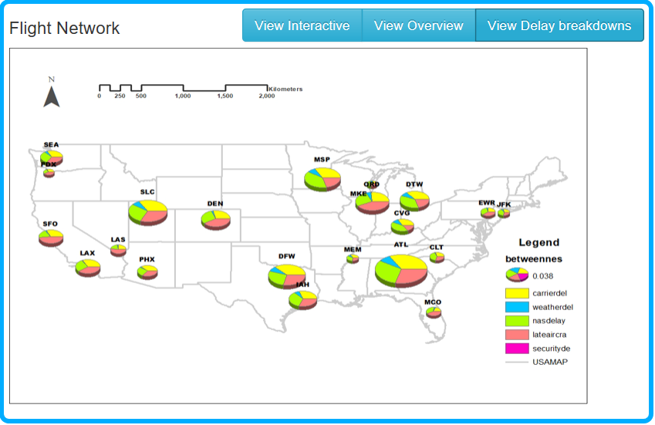

**Figure 3.2.3: Delay Reasons for High Betweenness Airports In 2008**

**Purpose:** By using **ArcGIS** created Geo-spatial layout combined with pie charts which will represent airports and the percentage of different delay reasons: Carrier delay, Weather delay, NAS delay, Security delay and Late Aircraft delay for higher betweenness airports.

**Nodes**: By using betweenness centrality analysis to choose the airports with high betweenness values, and identified these airports in different size of nodes (Pie chart).

The pie chart of each node shows the percentages of different delay reasons.

**Analysis:** It is clear to conclude from the figure that the ATL (William B Hartsfield-Atlanta International Airport) is the most critical airport to the overall flight network, and the main reasons of delay in ATL caused by carried delay, late aircraft delay and weather delay. The weather delay reason has high proportion in the centre of the continent but less in costal cites.

**Pros:**

* Shows proportions of each delay reason at airport
* Visualisation represent percentage of each delay reasons of overall delay reasons

**Cons:**

* Visualisation don’t show for all airports
* Not interactive visualisation, Static visualisation

### 3.2.4 Visualisation 4: Seasonal Effect

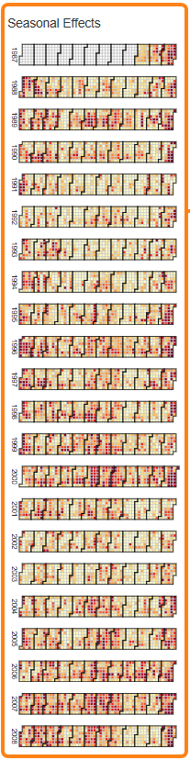

**Purpose:** Calendar view of flight delay to show overall flight delay by day/month/year over 21 years to show which is best and worst time for travel in USA.

**Analysis:** Each day represented by squares and **heat map** technique will be used to depict flight delay percentage for the day. This visualization is showing a heat map of percentage of delays over 20 years from the year of 1987 to 2008 and developed in D3. Each day is represented by little square, each square is filled with different colour to distinguish the delays between each day. The darker the colour represents more delay, similarly the lighter colour represents less delay for that day.

It also gives some useful hints for viewers, e.g. it can be easily seen that usually the September and the October months have light colours meaning these two months are best two months for travelling throughout the whole year. Similarly Dec and Jan worst time to fly as have dark colours almost every day.

**Pros:**

* Easy to understand for user
* Shows entire 21 years of data and trend of flight delays

**Cons:**

* Not interactive visualisation, Static visualisation
* Can’t get detail of every day delay percentage and delay reasons

**Figure 3.2.4: Seasonal Effect**

### 3.2.5 Visualisation 5: Airline Performance

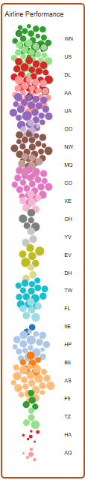

**Purpose:** Using D3, bubble chart to represent airline performance year on year. It helps traveller which airline to avoid while travelling.

**Nodes**: Each cluster/colour represents airline, and the circle size to represent % delay. Top 20 airlines performance shown from 1987 to 2008.

**Analysis:** Force directed algorithmis used to show good quality node size graph and simple for analysis. This is interactive graph, clicking on each node gives following information.

* Carrier:
* Year:
* Total Flights:
* Num of Delays:
* Delay %:

From visualization EV (Atlantic Southeast Airlines) looks worst airline and HA (Hawaiian Airlines Inc.) looks best airline.

**Pros:**

* Easy to understand for user
* Shows entire 21 years of data and trend of airline delays

**Cons:**

* Can’t get detail of every day delay percentage and delay reasons
* Show limited number of airlines, not all

**Figure 3.2.5: Best and**

**Worst airline**

### 3.2.6 Visualisation 6: Best/Worst Airport

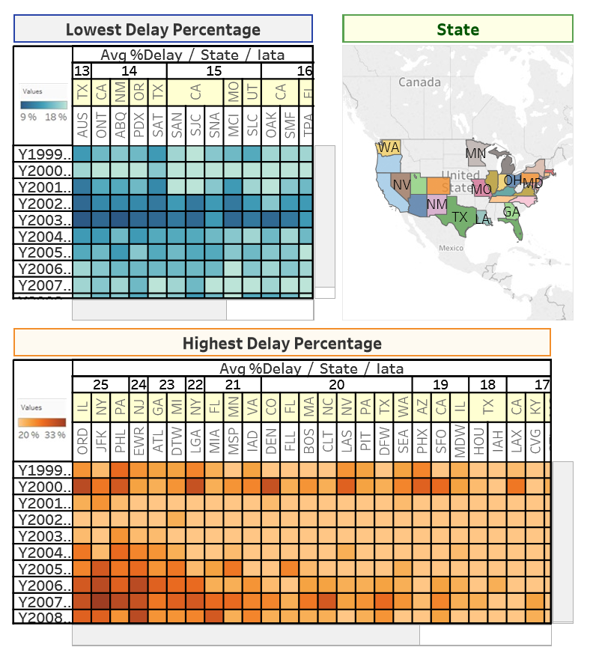

**Figure 3.2.6: Airports Performance**

**Purpose:** Present a heat map visualisation representing the performance of airports from each state of the United States by its percentage of flights being delayed, showing data ranging from 1999 to 2008. This visualisation is developed in Tableau.

**Analysis:**

**Lowest Delay Percentage Heat map**: Relative performance in the number of flights delayed, between 9% to 18%, is identified as different tones of green, with a darker tone indicating a lower percentage of delay and lighter tones indicating a higher percentage of delays. Hovering the mouse over an individual box will provide detailed information regarding the airport’s home state, full name, and exact delay percentage for the selected year row. As well as showing the average delay percentage for the whole year range of 1999 to 2008 of the entire column.

**Highest Delay Percentage Heat map**: Similarly, the relative performance in percentage of delays is identified using different tones, this time representing the range between 20% and 33% and with the colour orange. Lighter tones show a lower percentage of delays and darker tones indicating higher percentage of delays. Again, same as for the Lowest Delay Percentage Heat map, hovering the mouse over an individual box will provide the airport’s home state, full name, the exact delay percentage for the year, and the average delay percentage of the entire year range.

**Airport in State of USA Map:**

The map shows every state of the US that possesses at least one airport and differentiates these states using different colours. Hovering the mouse over any one of these states will interactively highlight the same state column(s) (if found) on each heat map. Conversely hovering the mouse over any state of any of the heat maps will highlight exclusively that state on the map.

Also, highlighting a single airport of any of the heat maps will highlight the same airport column in the other heat map (if found) as well as highlight the state that airport belonged to on the map.

**Pros:**

* User interactive feature select any airport of top 20 to get more information
* Shows entire 21 years of data and trend of airline delays

**Cons:**

* Can’t get detail of every day delay percentage and delay reasons
* Show limited number of airlines, not all

### 3.2.7 Visualisation 7: Delay reasons and types Correlations

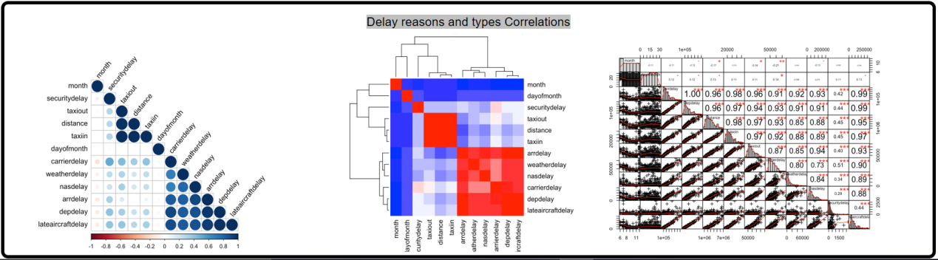

**Purpose:** By using **ArcGIS** created Geo-spatial layout combined with pie charts which will represent airports and the percentage of different delay reasons: Carrier delay, Weather delay, NAS delay, Security delay and Late Aircraft delay for higher betweenness airports.

**Nodes**: By using betweenness centrality analysis to choose the airports with high betweenness values, and identified these airports in different size of nodes (Pie chart).

The pie charts of each nodes shows the percentages of different delay reasons.

**Analysis:** To show effect of various delay reasons **Statistical Analysis** will be performed. Correlation Matrix to be generated for various dimensions like whether, security, distance etc. over the predicted value of flight delay. The purpose of this exercise is to identify and calculate the correlation figures associated with each delay reasons (% effect of reasons).

**scatter plot**utilising the **ggPlot library** in **R** is proposed as the best fit tool to carry out such analysis and visualisation.

4. Implementation

Following implementation plan followed to achieve the visualisations :

**Step 1. Extract & Load of data**

1. Download all data files from websites and put it in local drive.
2. Use PostgreSQL utility to import data into database.
3. Load all 21 years of flight delay data into Ontime table.
4. Load airport data into Airport table and carrier data into carrier table.
5. Check errors and remediate error while loading data.

**Step 2. Cleanse data & Create Indexes**

1. Verify data has been completely loaded and no errors.
2. Correct data type for all columns.
3. Create indexes for all important columns and combinations to allow fast retrieval of information (query performance).

|  |
| --- |
| # index samples |
|  | createindexyearon ontime(year); |
|  | createindexdateon ontime(year, month, dayofmonth); |
|  | createindexflightoriginon ontime (origin); |
|  | createindexflightdeston ontime (dest); |
|  | createindexflightarrdelayon ontime (arrdelay); |

**Step 3. Develop & test queries for each visualisation**

1. Develop queries required for each visualisation.

|  |  |
| --- | --- |
| # e.g. delay summary all airports | |
|  | | selectf.origin, f.destas destination, count(\*) as count, |
|  | | sum(arrdelay) as total\_arrival\_delay\_minutes, |
|  | | d.number\_of\_delays, |
|  | | (d.number\_of\_delays\*100)/count(\*) as delayPercentage |
|  | | from ontime f, |
|  | | (select origin, |
|  | | dest, |
|  | | count(arrdelay) as number\_of\_delays |
|  | | from ontime |
|  | | where arrdelay >15 |
|  | | and year=2008 |
|  | | group by origin, dest) d |
|  | | wheref.origin=d.originandf.dest=d.destand year=2008 |
|  | | group byf.origin, f.dest, d.number\_of\_delays; |
|  |
|  |
|  |
|  |
|  |

1. Get additional calculated/transformed data(e.g. % delay, performance percentage etc.)
2. Test and refine queries to get correct outputs
3. Download query results in csv, excel, graphml formats for easy port and load in visualisation tools.

**Step 4. Develop code or use software tools to visualise & perform testing**

1. Carry out network analysis in NetworkX (e.g. centrality calculations) where applicable.
2. Develop code or use tool(s) to generate visualisations (e.g. JavaScript for D3).
3. Generate an overview of the visualisation of complete data
4. Reduce, refine and iterate through visualisations until satisfactory results are produced.
5. Write code or use tool options to scalecolour, size, text, resolution and layout of visualisations.
6. Debug and QA code
7. QA visualisations.
8. Refine visualisationsand finalise.

**Step 5. Peer review**

1. Perform peer review of each visualisation.
2. Select top 2 visualisations.

**Step 6. Evaluate and finalise visualisation**

1. Perform Evaluation for each visualisation
2. Finalize visualisations for VA system as well as final report.

# 5. Evaluation

The table below outlines method utilised/followed for evaluation for each of the visualisation and the related tasks/aims associated.

Table 5.1: Evaluation template of each visualisation

|  |  |  |
| --- | --- | --- |
| **Data / Visualization** | **Task(s)** | **Evaluation Methods** |
| **Primary Flight Network**  Visualisation 1: Flight Network-View Overview  Visualisation 2: Flight Network-View Delay Breakdowns  Visualisation 3: Flight Network-View Interactive | Identify critical routes | **Survey** (Questionnaire, Interview, Focused group) |
| Identify critical airports |
| Summary of overall network |
| Visualisation 4: Seasonal Effect | Identify month(s) for travel | **Survey** (Questionnaire, Interview, Focused group) |
| Identify month(s) to avoid for travel |
| Visualisation 5: Airline Performance | Identify Best Airline | **Survey** (Questionnaire, Interview, Focused group)  **&**  **Empirical evaluation** (statistical analysis) |
| Identify Worst Airline |
| Visualisation 6: Best/Worst Airport | Identify best Airport | **Survey** (Questionnaire, Interview, Focused group)  **&**  **Empirical evaluation** (statistical analysis) |
| Identify Worst Airport |
| Visualisation 7: Delay reasons and types Correlations | Identify main reasons for flight delay | **Survey** (Questionnaire, Interview, Focused group)  &  **Empirical evaluation** (statistical analysis) |

## 5.1 Results

### 5.1.1 Survey (Questionnaire)

Following are survey form created by team and distributed to get feedback from classroom. This survey form created in **Google form** to get digital response(s).

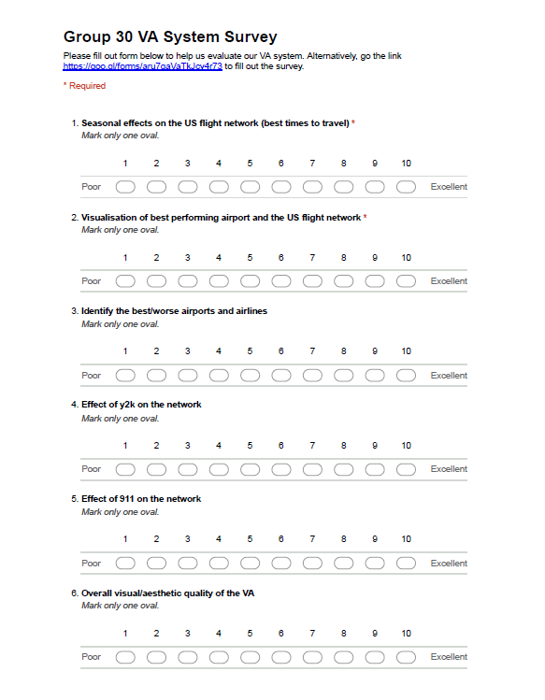



**Result (Questionnaires): 15 responses have been received, following is summary of response received, and details of each response are attached in appendix.**

**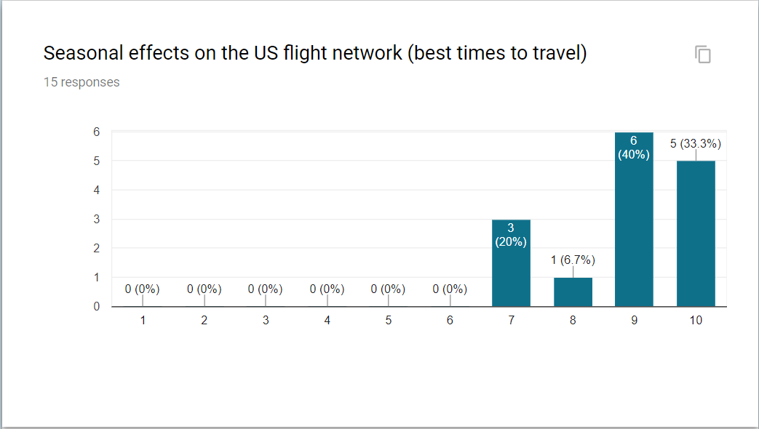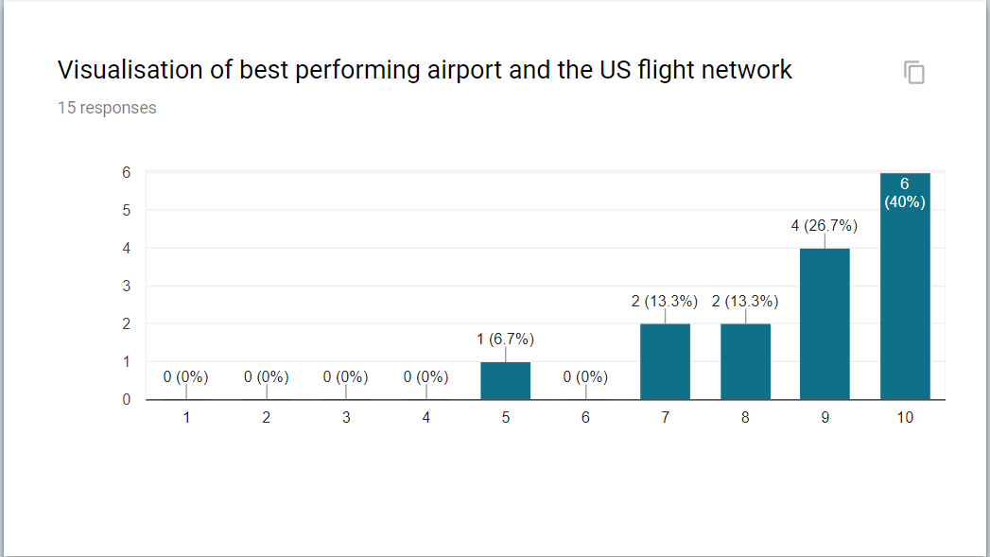**

**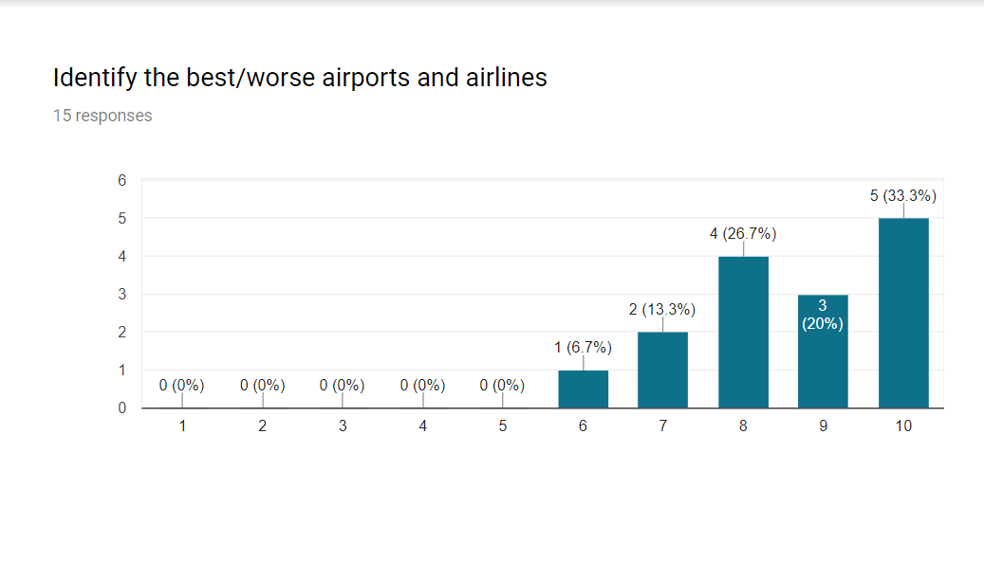**

**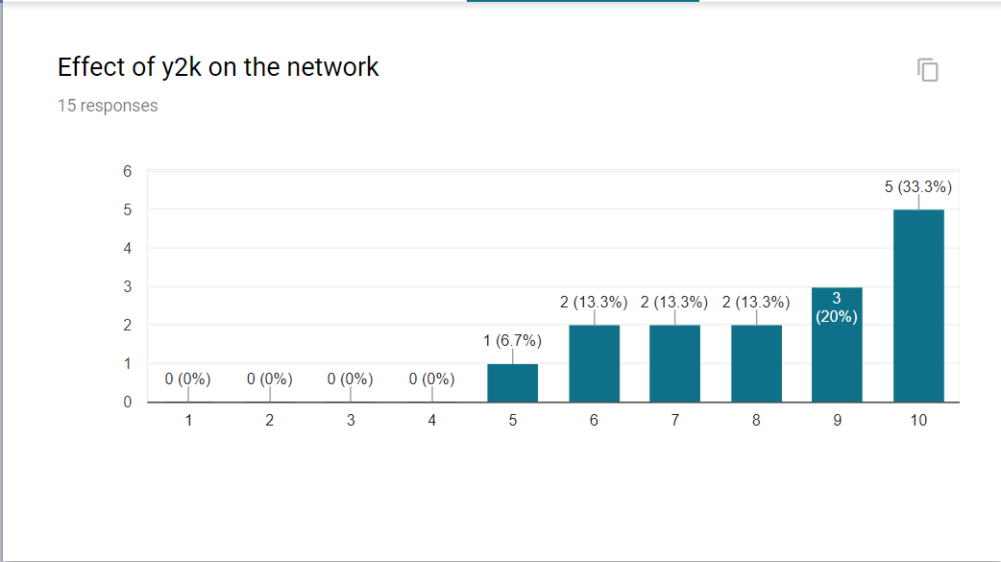**

**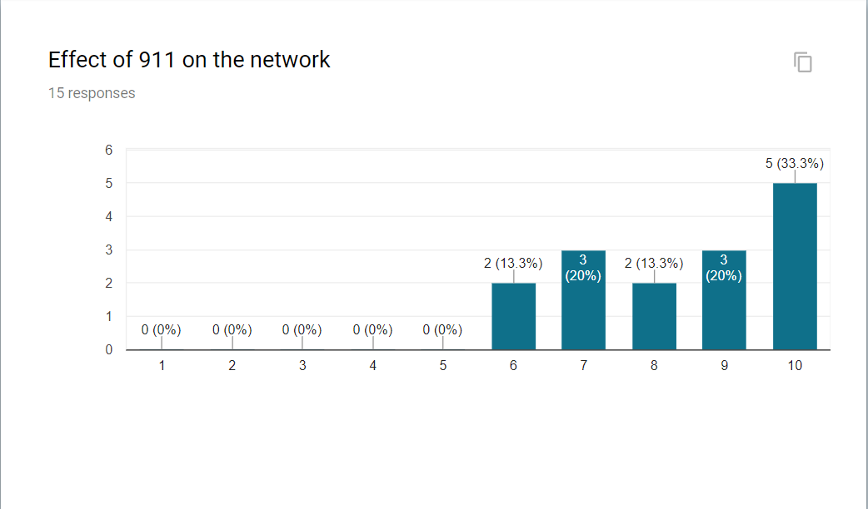**

**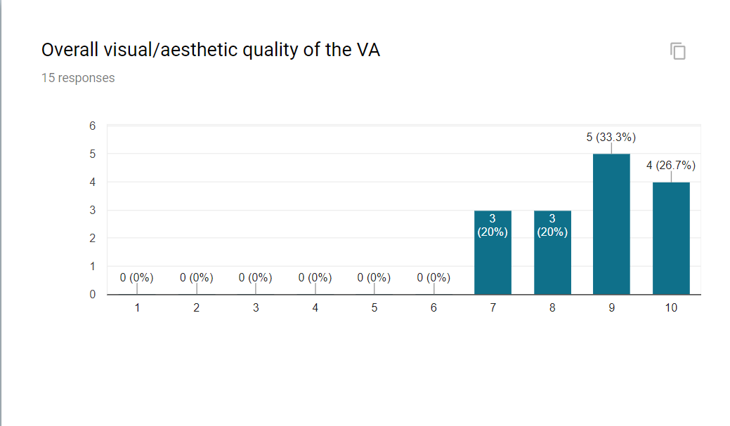**

**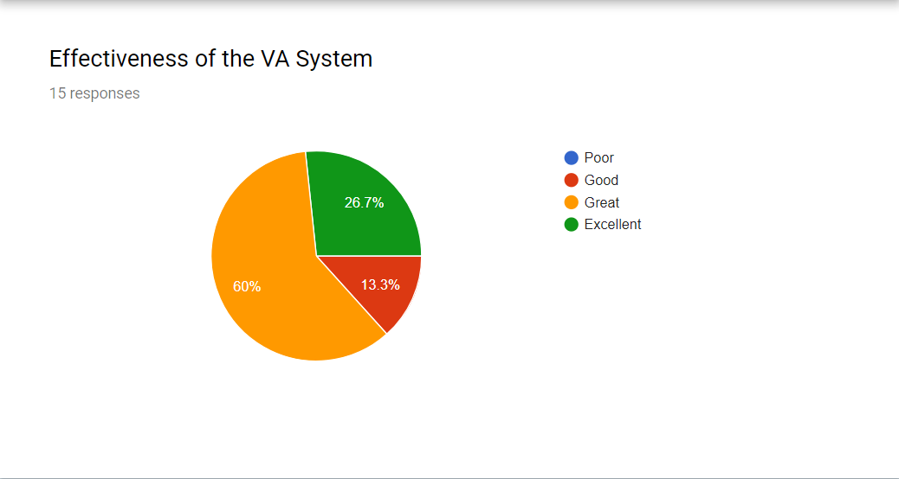**

### 5.1.2 Survey (Interview)

**Interview Results:**

|  |  |  |  |
| --- | --- | --- | --- |
| Name: | Shuhao | Interviewer: | Alan |
| Occupation: | Student | Time: | 19/10/2017 |
| Background: | | Irrelevant users | |
| Interview content: | | | |
| Hello. My name’s shuhao. I’m student.  Today, I attend this Interview for Group 30’s visualizations.  At first, when I read the overall visualization, the graph is very clear and informative. It involve plenty of information about flight line and delay reasons, something like that.  According to the first visualization, I can easily figure out when is the best month to go travelling actually. Each dayis represented by squares and shows flight delay percentage for the day. According to the size of the dataset, the calendar represents the delay data effectively and directly.  Two map visualizations are very attracting. The heat map shows the different airport sizes and different delay level. In the second map, colour scale indicates percentage delay. This interactive visualization contains the info from 1987 to 2008.SO great.  Followed by that, what I can call that? Bubble chart. Actually, I don’t see that kind of chart before. The appearance is very new. | | | |
| Suggestion: At last, I may give some suggestions. That is, the visualization could be tough and complex. If you could simply it, it could be better.  That’s all. | | | |

### 

### 5.1.3 Empirical evaluation (statistical analysis)

Statistical analysis has been performed using python code to prove visualization is working as expected -

1. **Best and Worst Airlines / Carriers :**

|  |  |
| --- | --- |
| **Statistical Analysis** | Best and Worst Airlines from Visualisation |
| **Null hypothesis (H0)** | The mean departure delays are the same for 2 airlines *Atlantic Southeast Airlines* and *Hawaiian Airlines Inc.* |
| **Alternative hypothesis** | The mean departure delays are different for 2 airlines *Atlantic Southeast Airlines* and *Hawaiian Airlines Inc.* (Mean departure delay for *Atlantic Southeast Airlines* is much higher than *Hawaiian Airlines Inc.*) |
| **Set α** | Significance level at 5% here. |
| **Compute p-value** | **ANOVA** P= 4.1059403272e-39 **Kruskall-Wallis H-test**  P= 1.20170973441e-21 |
| **Result** | We, therefore, have sufficient evidence to reject the null hypothesis. Our initial guess that a statistically significant difference existed in the means was backed by this statistical analysis. We have evidence to suggest that departure delay is related to carrier. |

1. **Best and Worst Airport :**

|  |  |
| --- | --- |
| **Statistical Analysis** | Best and Worst Airport from Visualisation |
| **Null hypothesis (H0)** | The mean departure delays are the same for 2 airport *ORD (IL)* and *AUS (TX)* |
| **Alternative hypothesis** | The mean departure delays are different for 2 airport *ORD (IL)* and *AUS (TX)* (Mean departure delay for *ORD (IL)* is much higher than *AUS (TX)* |
| **Set α** | Significance level at 5% here. |
| **Compute p-value** | **ANOVA**  P= 2.4974769606e-07  **. . .**  **Kruskall-Wallis H-test**  P= 2.49809315473e-13 |
| **Result** | We, therefore, have sufficient evidence to reject the null hypothesis. Our initial guess that a statistically significant difference existed in the means was backed by this statistical analysis. We have evidence to suggest that departure delay is related to Airport. |

1. **Delay Reasons :**

|  |  |
| --- | --- |
| **Statistical Analysis** | Delay Reasons Visualisation |
| **Null hypothesis (H0)** | The departure delays have same effect for following delay reasons   * Weather delay * Nas delay |
| **Alternative hypothesis** | The departure delays are different for 2 delay reasons  Mean departure delay for reason Nas delay is much higher than Weather delay |
| **Set α** | Significance level at 5% here. |
| **Compute p-value** | **ANOVA**  P= 2.27958149583e-09  **. . .**  **Kruskall-Wallis H-test**  P= 3.0630118343e-17 |
| **Result** | We, therefore, have sufficient evidence to reject the null hypothesis. Our initial guess that a statistically significant difference existed in the means was backed by this statistical analysis. We have evidence to suggest that departure delay is varies based on delay reasons. |

## 5.2 Discussion

# 6. Conclusion

# 

# 7. References

Following are website/documents referred for this assignment.

* Force Layout Multiples   
  <https://bl.ocks.org/mbostock/1804889>
* Congestion in the sky – Data expo winner <http://stat-computing.org/dataexpo/2009/posters/wicklin-allison.pdf>
* Data Expo runner up – flight data <http://stat-computing.org/dataexpo/2009/posters/hofmann-cook.pdf>
* Data Expo runner up 2 – flight data <http://stat-computing.org/dataexpo/2009/posters/wickham.pdf>
* Minimizing Flight Delay - Tanujit Dey • David Phillips • Patrick Steele  
  <http://stat-computing.org/dataexpo/2009/posters/dey-phillips-steele.pdf>
* Circular Heat map - <https://github.com/prcweb/d3-circularheat>
* Interactive flight network visualisation <http://mbostock.github.io/d3/talk/20111116/airports.html>
* Interactive flight network visualisation using google fusion tables  
  <http://xliberation.com/googlecharts/d3flights.html>
* Circular Visualisation D3   
  <https://github.com/nicgirault/circosjs>

# 8. Appendix: Group meeting minutes

|  |  |
| --- | --- |
| **Assignment 2 Kick off Meeting Minutes-Week7** | |
| Date | 14September 2017 |

**Present**:

|  |  |  |  |  |  |
| --- | --- | --- | --- | --- | --- |
| Alan Shen | X | Girishkumar Dhotarkar | X | Nagib Shah | X |
| Qiushi Zhang | X | Xinan (Langley) Ma | X | Young Choi | X |

**Minutes**

|  |  |  |  |
| --- | --- | --- | --- |
| **Agenda** | | * Introduce Group Members * Nominate Roll * Select Data Sets * Discuss software, tool, method.. * Further planning and goal setting | |
| **Outcome** | | * **Suggestions:**  1. Choose Flights data set (flight delay data):    * Loaded data set in SQL Data base    * Analysis of the data 2. Come up with 2 Questions from each member    * Due by 5:00 pm 16 Sep 2017 (Sat) 3. Method of communication using WhatsApp 4. Share information using github.com | |
| **Actions** | | * Loded data set to Data base   + Nagib * Try to ArcGIS   + Langley * Meeting Minutes   + Young * Data analyse   + everyone | |
| **Conclusion(s)** | | We have very short time so we have the keep the momentum which is essential. | |
| **Assignment 2 Meeting Minutes-Week7** | | |
| Date | 16September 2017 | |

**Present**:

|  |  |  |  |  |  |
| --- | --- | --- | --- | --- | --- |
| Alan Shen | X | Girishkumar Dhotarkar | X | Nagib Shah | X |
| Qiushi (Rachel) Zhang | X | Xinan (Langley) Ma | X | Young Choi | X |

**Minutes**

|  |  |
| --- | --- |
| **Agenda** | * Select Proposal Questions * Discuss Data set * Further planning and goal setting |
| **Outcome** | * **Suggestions:**  1. Come up with Paper Drawing for Frame from each member 2. Next meeting time    * 18 Sep 2017 (Mon) at 9:30 pm  * **Confirmed Proposal Questions:**  1. What is the best time for travelling? (seasonal?, weekdays/weekends?) 2. Time-lapse series of graph showing performance of airports (year to year)    * Find the worse performing airport?    * Find the worse performing airline?    * City/airport performance for a single year (heatmap)    * Effect of the airline/airport delay and performance during 1999 – 2000 (y2k bug) 3. Find the best/worse performing airline/carrier |
| **Actions** | * Exporting fromdata baseinto CSV format   + Nagib, Girishkumar * Visualise using Python/Gephi/yEd   + Nagib * Visualise using ArcGIS   + Langley * Visualise usingCalandar View   + Rachel * Visualise usingECharts   + Alan * Visualise using Tableau   + Young * Meeting Minutes   + Young * Draft initial report   + Girishkumar * Data analysis based on confirmed proposals   + everyone |
| **Conclusion(s)** | We had kept the momentum and were very productive. |

|  |  |
| --- | --- |
| **Assignment 2 Meeting Minutes-Week8** | |
| Date | 18September 2017 |

**Present**:

|  |  |  |  |  |  |
| --- | --- | --- | --- | --- | --- |
| Alan Shen | X | Girishkumar Dhotarkar | X | Nagib Shah | X |
| Qiushi (Rachel) Zhang | X | Xinan (Langley) Ma | X | Young Choi | X |

**Minutes**

|  |  |
| --- | --- |
| **Agenda** | * Discuss Drafted Design and Visualisation * FinaliseApproach for Design and visualisation |
| **Outcome** | * **Discussion:**  1. Discussed Following are few design and visualisation  * Best Time to Fly - Wheel Lay-Out By Nagib * Worst Performing Airport – Heat Map by Alan * Airline On time Performance – Young  1. Next meeting time    * 21 Sep 2017 (Mon) at 9:00 pm |
| **Actions** | * Generate visualisation for each of questions along with analysis technique and visualisation lay-out   + Nagib   + Girishkumar   + Langley   + Rachel   + Alan   + Young * finalise best design and visualisation out of all – Whole team by discussion |
| **Conclusion(s)** | We are ahead of game, Keep Momentum same. |

|  |  |
| --- | --- |
| **Assignment 2 Meeting Minutes-Week8** | |
| Date | 21 September 2017 |

**Present**:

|  |  |  |  |  |  |
| --- | --- | --- | --- | --- | --- |
| Alan Shen | X | Girishkumar Dhotarkar | X | Nagib Shah | X |
| Qiushi (Rachel) Zhang | X | Xinan (Langley) Ma | X | Young Choi | X |

**Minutes**

|  |  |
| --- | --- |
| **Agenda** | * Show and describe everyone’s own Paper Drawing for Frame * Discuss VA diagram and Visualization * Assign tasks for Design and visualization |
| **Outcome** | * **Suggestions:**  1. Assign each one’ work and show the faced question in next meeting  * **Discussion:**  1. Discussed and determined the data, tip&summary, tools and frame 2. Discussed whether following VA visualizations are proper design  * The overview map(with top 10 airports)—d3 * The map-ArcGIS * Daily heatmap(Calendar)-d3 * Bubble chart(with top 10 airlines) * Coordination matrix(with security,weather and so on) * GGPlot-R * Bar chart-tableau * Line chart-tableau |
| **Actions** | * Discuss and choose the proper visualisation in the frame design * Complete best frame design and assign visualisation out of all   + Nagib   + Girishkumar   + Langley   + Rachel   + Alan   + Young |
| **Conclusion(s)** | Everything is perfect. Fighting. |

|  |  |
| --- | --- |
| **Assignment 2 Meeting Minutes-Week8** | |
| Date | 26 September 2017 |

**Present**:

|  |  |  |  |  |  |
| --- | --- | --- | --- | --- | --- |
| Alan Shen | X | Girishkumar Dhotarkar | X | Nagib Shah | X |
| Qiushi (Rachel) Zhang | X | Xinan (Langley) Ma | X | Young Choi | X |

**Minutes**

|  |  |
| --- | --- |
| **Agenda** | * Review Group30 Initial Report * Discuss VA diagram and Visualization * Signed up Cover Sheet |
| **Outcome** | * **Suggestions:**  1. Final reviw Initial Report befornext meeting (27/9/2017 at 9:30 pme)  * **Discussion:**  1. Reviewand discussion following VA visualizationsdesign  * The overview map(with top 10 airports)—d3 * The map-ArcGIS * Daily heatmap(Calendar)-d3 * Bubble chart(with top 10 airlines) * Coordination matrix(with security,weather and so on) * GGPlot-R * Bar chart-tableau * Line chart-tableau |
| **Actions** | * Discuss and continue implement visualisation in the frame design * Final review Initial Report before summit   + Nagib   + Girishkumar   + Langley   + Rachel   + Alan   + Young |
| **Conclusion(s)** | We are good progress and very productive. |

|  |  |
| --- | --- |
| **Assignment 2 Meeting Minutes-Week8** | |
| Date | 27 September 2017 |

**Present**:

|  |  |  |  |  |  |
| --- | --- | --- | --- | --- | --- |
| Alan Shen | X | GirishkumarDhotarkar | X | Nagib Shah | X |
| Qiushi (Rachel) Zhang | X | Xinan (Langley) Ma | X | Young Choi | X |

**Minutes**

|  |  |
| --- | --- |
| **Agenda** | * Review the Group30 Initial Report |
| **Outcome** | * **Discussion:**   + Discuss each section of initial report and finalise final draft |
| **Actions** | * Final review of Initial Report   + Nagib   + Girishkumar   + Langley   + Rachel   + Alan   + Young * Submission of Initial Report   + Langley |
| **Conclusion(s)** | First assignment for initial report now completed |

|  |  |
| --- | --- |
| **Assignment 2 Meeting Minutes-Week9** | |
| Date | 5October 2017 |

**Present**:

|  |  |  |  |  |  |
| --- | --- | --- | --- | --- | --- |
| Alan Shen | X | Girishkumar Dhotarkar | X | Nagib Shah | X |
| Qiushi (Rachel) Zhang | X | Xinan (Langley) Ma | X | Young Choi | X |

**Minutes**

|  |  |
| --- | --- |
| **Agenda** | * Discuss the presentation strucutre |
| **Outcome** | * **Discussion:**   + Discuss each section of presentation and figure out the content |
| **Actions** | * **Suggestions:**  1. Assign each one’ work and show different parts in next meeting  * **Discussion:**  1. Discussed and determined the structure of slides 2. Determined the outline according to the requiremtn and added more detail  * Introduction * Design * Implementation * Evaluation * Progress * Planning |
| **Conclusion(s)** | The overall presentation structure was determined |

|  |  |
| --- | --- |
| **Assignment 2 Meeting Minutes-Week9** | |
| Date | 6October 2017 |

**Present**:

|  |  |  |  |  |  |
| --- | --- | --- | --- | --- | --- |
| Alan Shen | X | GirishkumarDhotarkar | X | Nagib Shah | X |
| Qiushi (Rachel) Zhang | X | Xinan (Langley) Ma | X | Young Choi | X |

**Minutes**

|  |  |
| --- | --- |
| **Agenda** | * Detail content of slides * Discuss the different way of the presentation |
| **Outcome** | * **Discussion and Assignment:**   + Discuss detailed method to show our presentation   + Make sure the presentation is attractive |
| **Actions** | * **Discussion:**   + Discuss introduction   + To begin with a moive or question to attrat audience   + Disucss the method to show our VA system   + Assign everyone work of the presentation part |
| **Conclusion(s)** | 50% of Presentation part is completed |

|  |  |
| --- | --- |
| **Assignment 2 Meeting Minutes-Week9** | |
| Date | 9October 2017 |

**Present**:

|  |  |  |  |  |  |
| --- | --- | --- | --- | --- | --- |
| Alan Shen | X | Girishkumar Dhotarkar | X | Nagib Shah | X |
| Qiushi (Rachel) Zhang | X | Xinan (Langley) Ma | X | Young Choi | X |

**Minutes**

|  |  |
| --- | --- |
| **Agenda** | * Practice and review the presentation part |
| **Outcome** | * **Practice & Review:**   + Practice the presentation   + Review the slides |
| **Actions** | * Final review of Presentation Slides * Practice the presentation   + Nagib   + Girishkumar   + Langley   + Rachel   + Alan   + Young * Submission of Slides   + Langley |
| **Conclusion(s)** | Presentation part now completed |

|  |  |
| --- | --- |
| **Assignment 2 Meeting Minutes-Week10** | |
| Date | 12October 2017 |

**Present**:

|  |  |  |  |  |  |
| --- | --- | --- | --- | --- | --- |
| Alan Shen | X | Girishkumar Dhotarkar | X | Nagib Shah | X |
| Qiushi (Rachel) Zhang | X | Xinan (Langley) Ma | X | Young Choi | X |

**Minutes**

|  |  |
| --- | --- |
| **Agenda** | * Discuss the final report strucutre |
| **Outcome** | * **Discussion:**   + Discuss each section of final report and add detail |
| **Actions** | * **Suggestions:**  1. Assign everyone’s work and show different parts in next meeting  * **Discussion:**  1. Discussed and determined the structure of final report 2. Determined the outline according to the requiremtn and figure out the contents  * Aims and Contribution * Data set * Design * Implementation * Evaluation * Conclusion |
| **Conclusion(s)** | Start the final report |

|  |  |
| --- | --- |
| **Assignment 2 Meeting Minutes-Week11** | |
| Date | 20 Oct 2017 |

**Present**:

|  |  |  |  |  |  |
| --- | --- | --- | --- | --- | --- |
| Alan Shen | X | Girishkumar Dhotarkar | X | Nagib Shah | X |
| Qiushi (Rachel) Zhang | X | Xinan (Langley) Ma | X | Young Choi | X |

**Minutes**

|  |  |
| --- | --- |
| **Agenda** | * Discuss and Add detail to the final report draft |
| **Outcome** | * **Discussion:**   + Discuss and Focus on the evaluation part |
| **Actions** | * **Suggestions:**  1. Assign each one’ work about the evaluation part and give everyone’s own opinion  * **Discussion:**  1. Discussed and determined the methods of evaluation 2. Discussed the result of evluation 3. Discussed the questions about the evaluation  * How about seasonal effects on the US flight network (best times to travel) * How about visualisation of best performing airport and the US flight network * Identify the best/worse airports and airlines * How about effect of y2k on the network * How about effect of 911 on the network * How about overall visual/aesthetic quality of the VA * How about effectiveness of the VA System |
| **Conclusion(s)** | 80% of final report now completed |

|  |  |
| --- | --- |
| **Assignment 2 Meeting Minutes-Week12** | |
| Date | 27October 2017 |

**Present**:

|  |  |  |  |  |  |
| --- | --- | --- | --- | --- | --- |
| Alan Shen | X | Girishkumar Dhotarkar | X | Nagib Shah | X |
| Qiushi (Rachel) Zhang | X | Xinan (Langley) Ma | X | Young Choi | X |

**Minutes**

|  |  |
| --- | --- |
| **Agenda** | * Review the Group30 Final Report |
| **Outcome** | * **Discussion:**   + Discuss each section of final report and finalise final draft |
| **Actions** | * Final review of Final Report of Assignment 2   + Nagib   + Girishkumar   + Langley   + Rachel   + Alan   + Young * Submission of Final Report   + Langley |
| **Conclusion(s)** | 100% of Final report now completed |

|  |  |
| --- | --- |
| **Assignment 2 Meeting Minutes-Week12** | |
| Date | 27October 2017 |

**Present**:

|  |  |  |  |  |  |
| --- | --- | --- | --- | --- | --- |
| Alan Shen | X | Girishkumar Dhotarkar | X | Nagib Shah | X |
| Qiushi (Rachel) Zhang | X | Xinan (Langley) Ma | X | Young Choi | X |

**Minutes**

|  |  |
| --- | --- |
| **Agenda** | * Review the Group30 Final Report |
| **Outcome** | * **Discussion:**   + Discuss each section of final report and finalise final draft |
| **Actions** | * Final review of Final Report of Assignment 2   + Nagib   + Girishkumar   + Langley   + Rachel   + Alan   + Young * Submission of Final Report   + Langley |
| **Conclusion(s)** | 100% of Final report now completed |

# 9. Appendix: Code